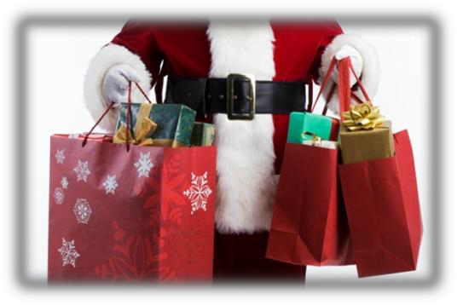
SANTA’S BAG ARTS & CRAFTS SHOW
NOVEMBER 11, 2023
9:00 AM – 2:00 PM
SANTA’S BAG IS BACK!
Enclosed are your 2023 Santa’s Bag Arts and Crafts Show application and the Rules & Guidelines for this year’s show.
Show Date: Saturday, November 11, 2023
Show Location: Marshall High School Application Deadline: June 24, 2023

If the show is not full by the deadline, I will continue accepting applications. If you have any special requests (electricity, a certain booth number, a certain area, etc.) it is highly recommended that you get your application in as soon as possible.

Do not hesitate to call me at The Fountain Clinic or send me an e-mail (see below) with any additional questions or concerns, I would be more than happy to help.

At the request of Marshall High School-there will NOT be any booths in the gym.

There will be a concession stand with fruit, hand held items, chips and drinks.

The sooner we get your application and check, the more likely we will be able to honor your booth request.

Thank you and we hope to see you in November!

Sincerely,

Linda Daily
Santa’s Bag Chair
269-789-0410
ldaily@fountain-clinic.org

