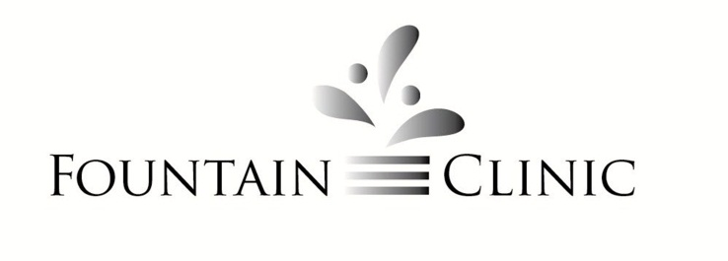
111 N. Jefferson St. – Marshall, MI 49068 – 269.781.0952

NOTICE OF PRIVACY PRACTICES
Patient Acknowledgement

Patient Name: ___________________________________________Date of Birth: ________________
I have received this practice’s Notice of Privacy Practices written in plain language. The notice provides in detail the uses and disclosures of my protected health information that may be made by this practice, my individual rights and the practice’s legal duties with respect to my protected health information. The notice includes:
- A statement that this practice is required by law to maintain the privacy of protected health information.
- A statement that this practice is required to abide by the terms of the notice currently in effect.
- Types of uses and disclosures that this practice is permitted to make for each of the following purposes: treatment, payment, and health care operations.
- A description of uses and disclosures that are prohibited or materially limited by law.
- A description of other use and disclosures that will be made only with my written authorization and that I may revoke such authorization.
- My individual rights with respect to protected health information and a brief description of how I may exercise these rights in relation to:
  - The right to complain to this practice and to the Secretary of HHS if I believe my privacy rights has been violated, and that no retaliatory actions will be used against me in the event of such a complaint.
  - The right to request restrictions on certain uses and disclosures of my protected health information, and that this practice is not required to agree to a requested restriction.
  - The right to receive confidential communications of protected health information.
  - The right to inspect and copy protected health information.
  - The right to receive and accounting of disclosures of protected health information.
  - The right to amend protected health information.
  - The right to obtain a paper copy of the Notice of Privacy Practices from this practice upon request.
This practice reserves the right to change the terms of its Notice of Privacy Practices and to make new provisions effective for all protected health information that it maintains. I understand that I can obtain this practice’s current Notice of Privacy Practices on request.

Signature: _______________________________________________Date: ______________________
Relationship to patient (if signed by a personal representative of patient): ______________________

